A* Search Algorithm and Best First Search Algorithm

# **AIM**

To implement pathfinding algorithms: ***A\**** Algorithm and ***Best First Search*** Algorithm

# **ALGORITHM**

## A* Search

1. Initialize the open list  
2. Initialize the closed list  
 put the starting node on the open   
 list (you can leave its **f** at zero)  
3. While the open list is not empty  
 a) Find the node with the least **f** on the open list, call it "q"  
 b) Pop q off the open list.  
 c) Generate q's 8 successors and set their parents to q.  
 d) For each successor  
 i) If successor is the goal, stop search  
   
 ii) Else, compute both **g** and **h** for successor  
 successor.**g** = q.**g** + distance between successor and q  
 successor.**h** = distance from goal to successor (This can

be done using many ways, we will discuss three

heuristics - Manhattan, Diagonal and Euclidean)  
  
 successor.**f** = successor.**g** + successor.**h**

iii) If a node with the same position as successor is in

the OPEN list which has a lower **f** than successor,

skip this successor  
 iv) If a node with the same position as successor is in

the CLOSED list which has a lower **f** than successor,

skip this successor otherwise, add the node to the

open list.  
 End (for loop)  
   
 e) Push q on the closed list  
 End (while loop)

## Best First Search

1. Initialization:
   * Create two lists:
     + OPEN: This is a priority queue to store unexpanded nodes.
     + CLOSED: This list stores nodes that have already been expanded.
   * Set the starting node (start_node) as the current node.
   * If a heuristic function (h(n)) is available, calculate h(start_node).
   * Add start_node to the OPEN list with its priority set to h(start_node) (if using a heuristic) or some other evaluation function.
2. Loop:
   * While the OPEN list is not empty:
     + 2.1. Expand Best Node:
       - Remove the node with the highest priority (lowest estimated total cost if using a heuristic) from the OPEN list and add it to the CLOSED list. This is the current node (current_node).
     + 2.2. Goal Check:
       - If current_node is the goal node, then return success (the goal has been found).
     + 2.3. Generate Successors:
       - Generate all possible successor nodes of current_node.
     + 2.4. Evaluate Successors:
       - For each successor node (successor):
         * If successor is already in CLOSED, skip it (already explored).
         * Calculate the cost (g(successor)) of reaching successor from the start node (e.g., number of steps taken).
         * If using a heuristic, estimate the remaining cost (h(successor)) to reach the goal from successor.
         * Calculate the total estimated cost (f(successor) = g(successor) + h(successor)).
         * Add successor to the OPEN list with its priority set to f(successor).
3. Search Failure:
   * If the loop finishes without finding the goal and the OPEN list is empty, then return failure (no solution exists).

# **CODE**

## A* Search

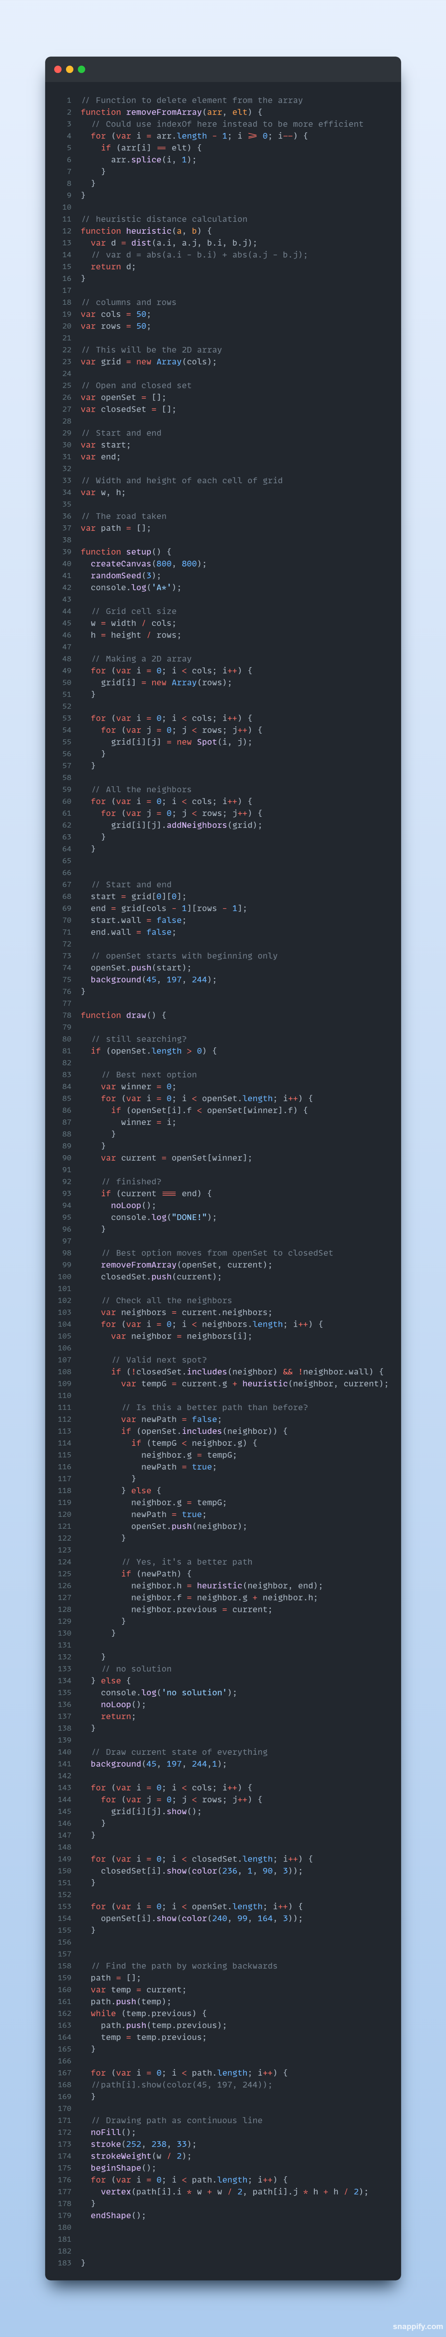

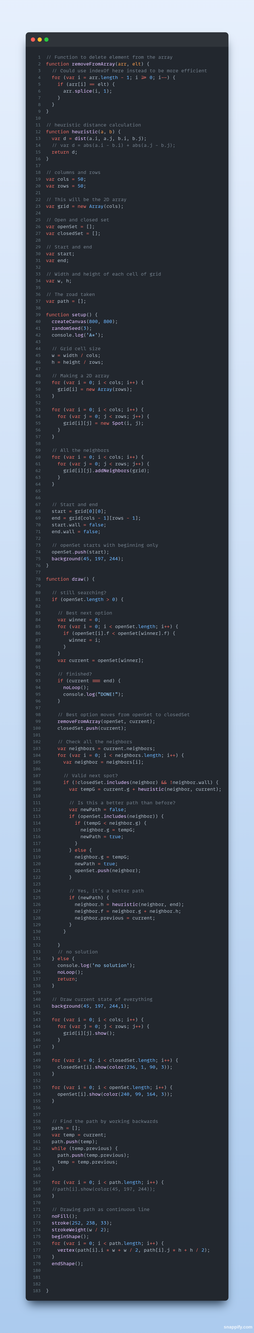

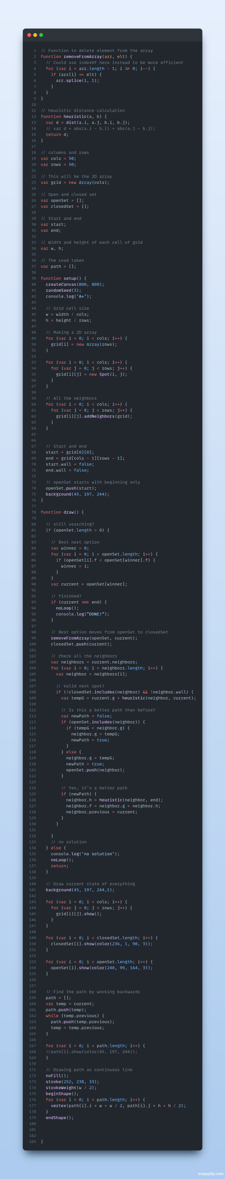

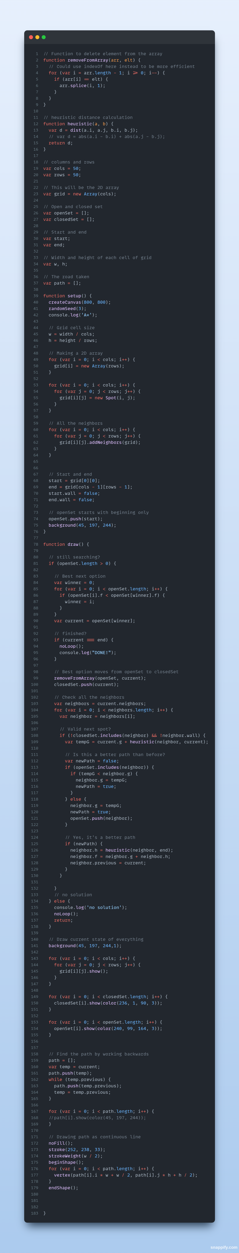

## Best First Search

Importing Modules

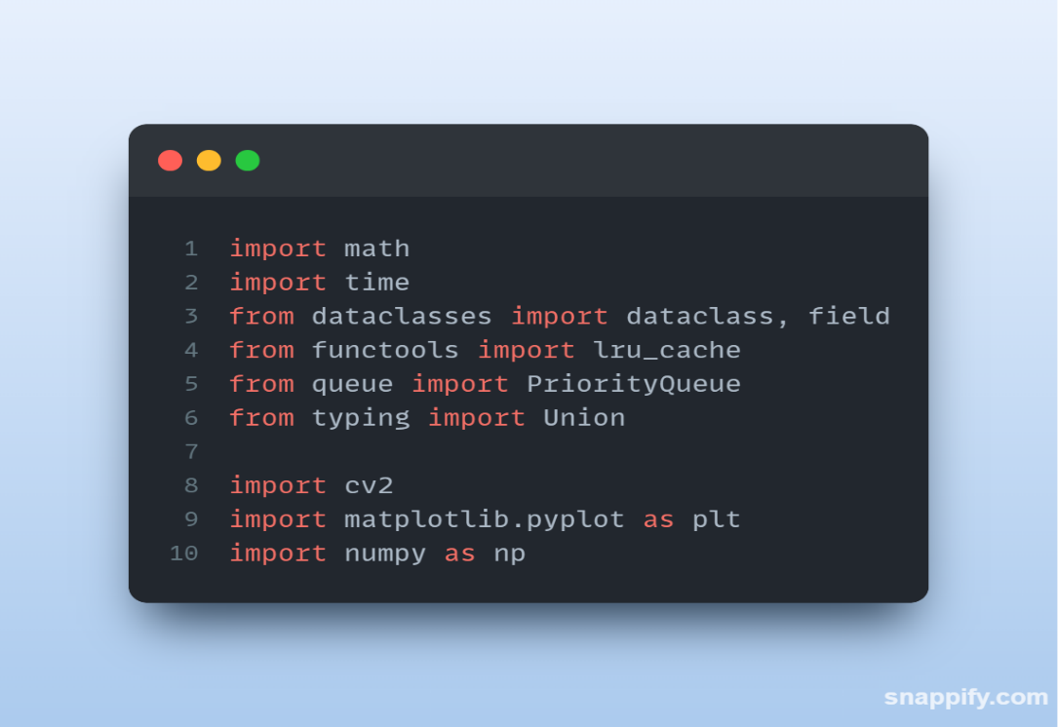

NODE DATACLASS

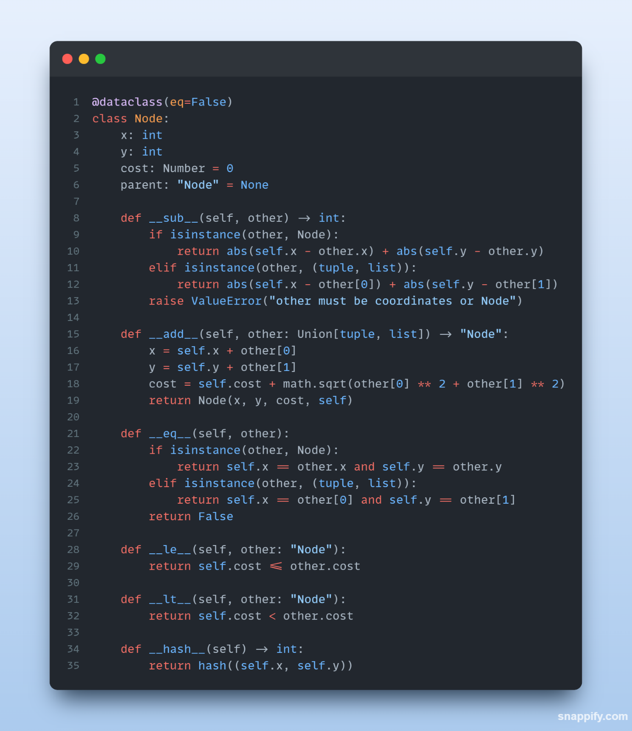

NODE DATACLASS

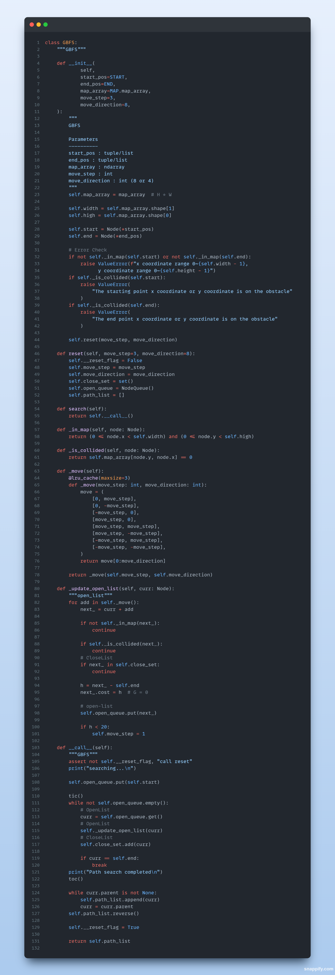

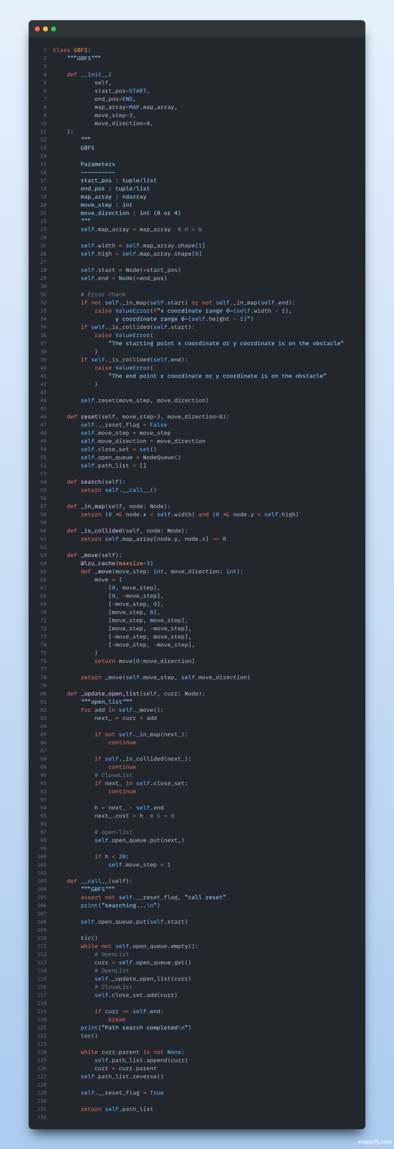

# **OUTPUT**

## A* Search



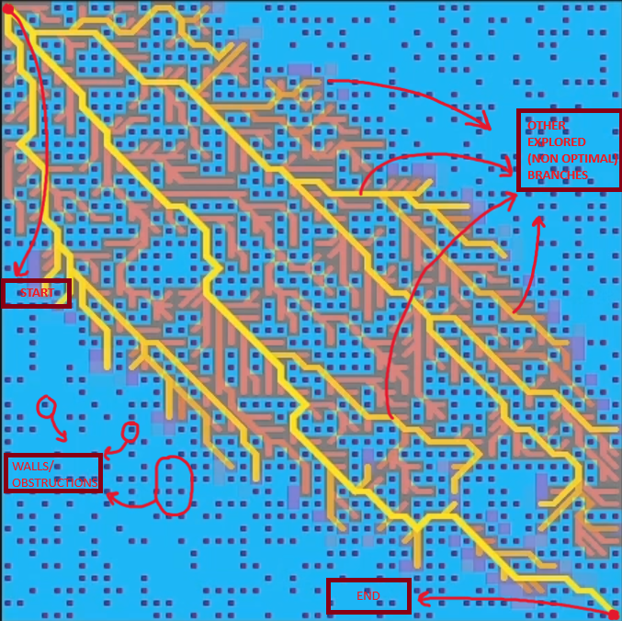

## Best First Search

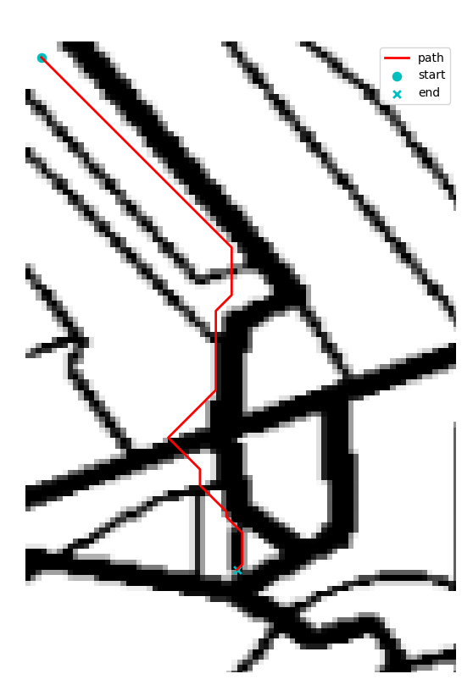

# **RESULT**

The A* Search and Best First Search Algorithms were implemented successfully.